SESSION 5 ASSIGNMENT 2

## PROBLEM 2

### Q2. Which month has seen the most number of cancellations due to bad weather?

REGISTER '/usr/local/pig/lib/piggybank.jar';

A = load 'DelayedFlights.csv' USING org.apache.pig.piggybank.storage.CSVExcelStorage(',','NO_MULTILINE','UNIX','SKIP_INPUT_HEADER');

A_LIMIT = LIMIT A 5;

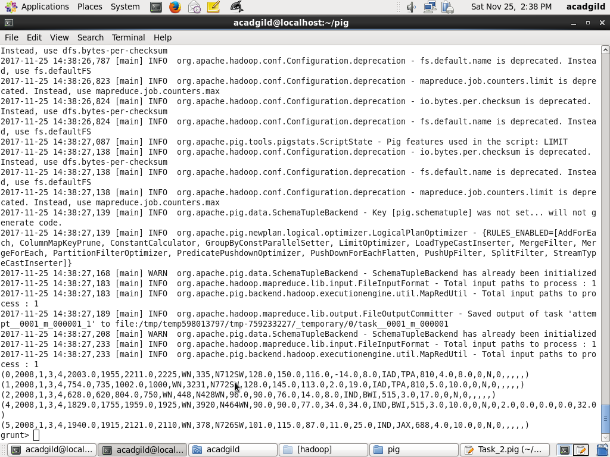

B = foreach A generate (int)$2 as month,(int)$10 as flight_num,(int)$22 as cancelled,(chararray)$23 as cancel_code;

B_LIMIT = LIMIT B 5;

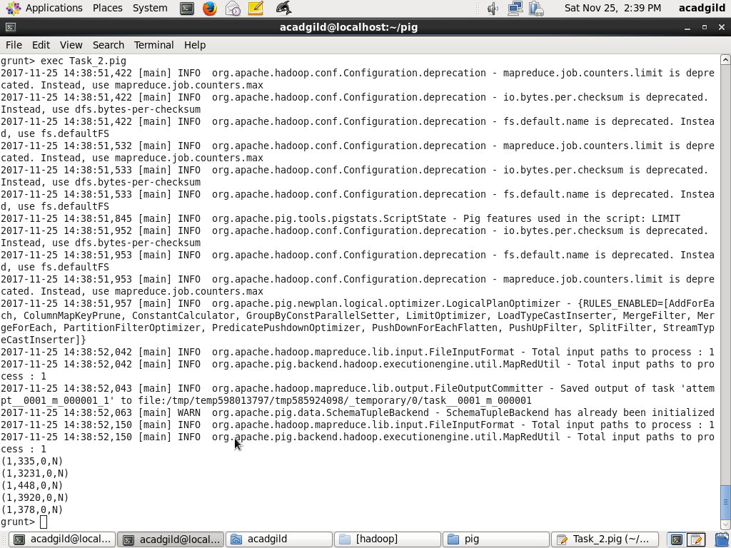

C = filter B by cancelled == 1 AND cancel_code =='B';

C_LIMIT = LIMIT C 5;

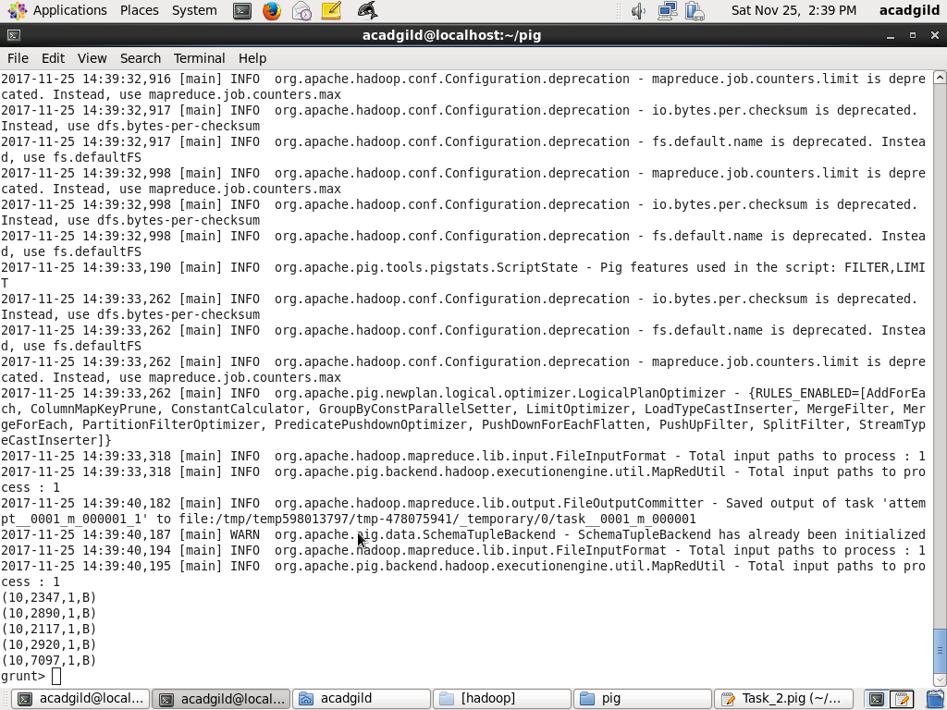

D = group C by month;

D_LIMIT = LIMIT D 5;

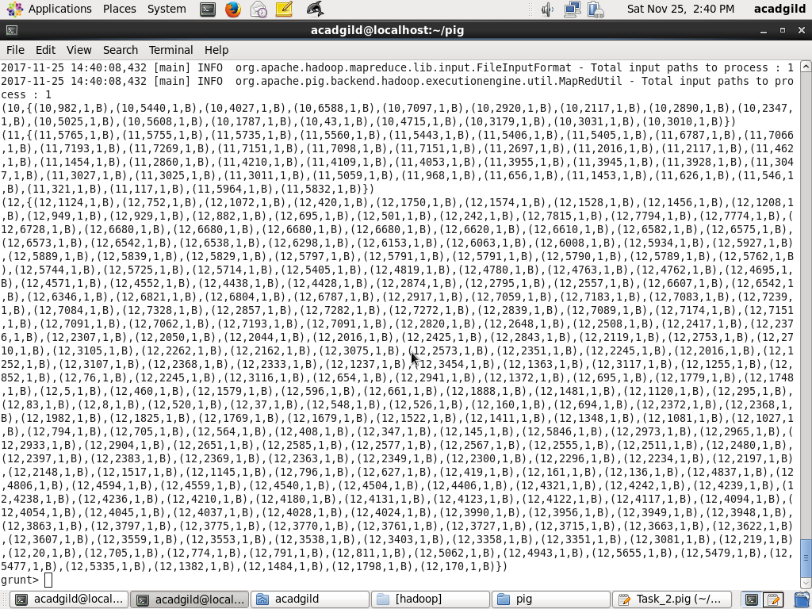

E = foreach D generate group, COUNT(C.cancelled);

E_LIMIT = LIMIT E 5;

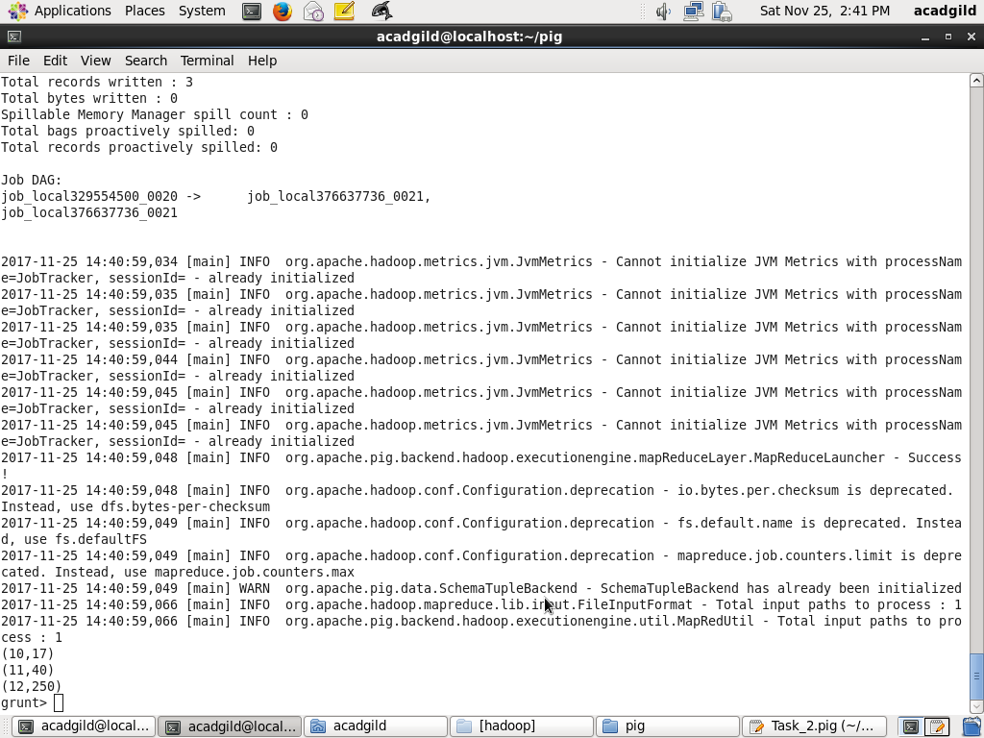

F= order E by $1 DESC;

Result = limit F 1;

dump Result;

